TARGET SENSING AND MISSILE
PREDICTION SYSTEM

UI design- Flutter(CS553PC) PROJECT REPORT
Submitted in partial fulfillment of the requirements for the
BACHELOR OF TECHNOLOGY

in
COMPUTER SCIENCE AND ENGINEERING(AIML)

by
JANGA DHANUNJAYA PRAKASH REDDY - 24261A6622
Under the guidance of

Mrs. K. Divija
(Assistant Professor)


Department of Emerging Technologies
MAHATMA GANDHI INSTITUTE OF TECHNOLOGY (A)
(Affiliated to Jawaharlal Nehru Technological University, Hyderabad, A.P .)
Chaitanya Bharathi P.O. Gandipet, Hyderabad – 500 075
2026

MAHATMA GANDHI INSTITUTE OF TECHNOLOGY (A)
(Affiliated to Jawaharlal Nehru Technological University, Hyderabad, A.P .)
Chaitanya Bharathi P.O. Gandipet, Hyderabad – 500 075

DEPARTMENT OF EMERGING TECHNOLOGIES
CERTIFICATE
This is to certify that the technical project report entitled " TARGET SENSING AND MISSILE PREDICTION SYSTEM” is a Bonafide academic work prepared by
J. DHANUNJAYA PRAKASH REDDY- 24261A6622
In partial fulfilment of the requirements for the Bachelor of Technology programme at Mahatma Gandhi Institute of Technology, Hyderabad, during the academic year 2026.
The report is submitted in partial fulfilment of the requirements for the award of Bachelor of Technology by Jawaharlal Nehru Technological University, Hyderabad during the academic year 2025-2026. The work presented has not been submitted elsewhere for the award of any degree or diploma.

Mrs. K. DIVIJA Dr. M. RAMA BAI
Assistant Professor Head of the Department

Abstract

The Target Sensing and Missile Prediction System is an environmental classification application developed using Flutter and Dart. It transforms the original ORBITAL concept into a responsive mobile and desktop interface, enabling users to enter geographical coordinates and environmental parameters, validate inputs, generate environmental snapshots, and visualize classification results.
The application uses a local deterministic classification algorithm to calculate normalized demonstration scores for three environmental categories: Air, Land, and Water. Results are displayed through percentage indicators and graphical probability bars. A session history feature allows users to review previous classification results and compare different environmental inputs.
Built using Flutter and Material Design 3, the application provides a modern interface with responsive layouts, structured input forms, environmental information cards, and interactive result panels. All processing is performed locally using Dart objects and predefined logic, without requiring external APIs, network connectivity, or a trained machine learning model.
The project demonstrates the complete application workflow, including input validation, local data processing, classification, and result visualization, while providing a foundation for future integration of real environmental datasets, machine learning models, and live environmental services.
All environmental values and classification results are simulated demonstrations and must not be used for actual environmental assessments or decision-making.

1. Introduction
1.1 Background
Modern applications require an efficient interface for collecting data and presenting results. Flutter enables the development of responsive applications for mobile, web, and desktop platforms using a single Dart codebase.
The proposed application demonstrates environmental classification using parameters such as temperature, humidity, wind speed, elevation, and terrain. Users can enter geographical coordinates, validate environmental inputs, and view classification results for Air, Land, and Water through graphical indicators.
The application uses locally generated environmental values and predefined classification rules to process inputs and display simulated results. It includes session history for reviewing previous classifications and provides a foundation for future integration of real environmental datasets and analytical capabilities.
1.2 Overview of the Proposed System
The Environmental Classification Application Using Flutter is designed to provide a single application for managing environmental inputs and classification activities.
The application allows users to access different functionalities through a structured dashboard. Each component performs a specific function related to environmental data processing and classification.
The system includes:
- Dashboard: Displays the project overview, environmental inputs, classification results, and session history.
- Location and Environment Management: Allows users to enter geographical coordinates and environmental parameters such as temperature, humidity, wind speed, and elevation.
- Environment Lookup: Generates a local simulated environmental snapshot based on the entered coordinates.
- Classification: Demonstrates environmental classification by generating normalized scores for Air, Land, and Water using predefined local rules.
- Results: Displays the leading classification category and corresponding scores through graphical progress indicators.
- Session History: Maintains recent classification results during the application session for reviewing previous inputs and outputs.
The Flutter application currently operates using local sample data and predefined logic. It demonstrates the frontend workflow, input validation, environmental data processing, and result visualization independently, without a live database, backend connection, trained model, or external environmental service.
1.3 Problem Statement
Managing environmental information and classification results requires a structured approach to data collection, validation, and visualization.
Some of the major challenges involved in this process include:
- Difficulty in validating geographical coordinates and environmental parameters.
- Generating environmental information without relying on external services.
- Maintaining consistency between terrain and atmospheric categories.
- Presenting classification scores in a clear and understandable format.
- Managing previous classification results within an application session.
- Separating application interface components from future backend integration.
Without proper input validation and clear result presentation, users may misunderstand simulated environmental outputs as actual environmental predictions.
Therefore, this project aims to develop a Flutter-based application that provides an organized interface for collecting environmental parameters, generating simulated environmental information, and displaying classification results for Air, Land, and Water.
1.4 Proposed Solution
The proposed solution is a modular Flutter application that brings environmental data collection, validation, classification, and result visualization together in a single interface.
Users can enter geographical coordinates and environmental parameters, generate a simulated environment snapshot, modify input values, and execute the classification process. The application displays the results through graphical indicators and maintains a temporary history of previous runs.
The system uses a local classification mechanism to calculate normalized scores for Air, Land, and Water categories. The application provides a structured interface for understanding environmental inputs and their corresponding classification outputs.
The current implementation operates independently using local Dart objects and predefined rules. Future integration with environmental APIs, real datasets, and trained models can extend the functionality of the application.

2. Objectives
The main objective of the Environmental Classification Application is to develop a responsive and organized digital platform for collecting environmental information, processing environmental parameters, and demonstrating classification results through an interactive interface.
The specific objectives are explained below.
2.1 Centralized Dashboard
To provide a single dashboard that summarizes environmental inputs, classification results, and recent application activity.
The dashboard serves as the main entry point of the application and provides access to the major functionalities without requiring users to navigate through multiple separate screens.
It presents environmental information, input controls, classification results, and session history in a structured format.
2.2 Environmental Data Management
To provide a structured interface for entering and managing geographical coordinates and environmental parameters.
Users can enter latitude, longitude, temperature, humidity, wind speed, and elevation through dedicated input fields.
The application validates the entered values and provides appropriate feedback whenever the information is missing or outside the supported range.
2.3 Environment Lookup
To demonstrate the generation of environmental information using geographical coordinates.
The application creates a local simulated environmental snapshot and populates the corresponding input fields with generated values.
Users can review the generated information and modify the values before executing the classification process.
2.4 Environmental Classification
To demonstrate the classification of environmental information into Air, Land, and Water categories.
The classification module processes environmental parameters through predefined local rules and calculates normalized scores for each category.
The application identifies the category with the highest score and presents it as the leading classification result.
2.5 Results and Performance Visualization
To provide a clear visual representation of classification outputs.
The application displays normalized scores through percentage indicators and graphical progress bars.
Users can compare the relative scores of Air, Land, and Water and understand the classification output generated for different environmental inputs.
2.6 Session History Management
To maintain a temporary record of classification activities performed during the current application session.
The history feature allows users to review previous inputs, classification results, and timestamps.
This functionality improves usability by providing access to recent application activity without requiring permanent database storage.

3. System Overview
The Environmental Classification Application is divided into multiple modules. Each module performs a specific function related to environmental data collection, validation, processing, classification, and result presentation.
3.1 Dashboard Module
The Dashboard module is the main screen of the application. It provides an overview of the project and acts as the starting point for accessing different functionalities.
The dashboard integrates environmental input controls, classification results, and session history into a single interface.
Main functionalities:
- Provides a centralized view of the application.
- Displays project information and scope.
- Provides access to environmental input fields.
- Shows classification results and graphical indicators.
- Displays recent classification activities.
- Organizes application functionalities into a structured layout.
Importance:
The dashboard improves accessibility by bringing the complete workflow into one screen. Users can enter environmental information, execute classification, and review results without navigating through multiple independent interfaces.
It also improves the overall user experience by maintaining a consistent visual structure and providing clear access to important application components.
3.2 Environmental Data Management Module
The Environmental Data Management module is responsible for collecting and validating environmental information entered by users.
The module uses structured form fields to accept geographical coordinates and environmental parameters required for classification.
The entered values are checked before they are processed by the application.
Main functionalities:
- Accepts latitude and longitude values.
- Accepts temperature and humidity information.
- Accepts wind speed and elevation values.
- Validates numerical inputs.
- Checks geographical coordinate ranges.
- Displays appropriate validation messages.
- Prevents invalid information from being processed.
Importance:
Environmental classification depends on the quality and consistency of the input information.
This module helps reduce invalid inputs and ensures that the application receives values within the supported ranges before executing the classification process.
It also provides a simple and organized interface for entering environmental information.
3.3 Environment Lookup Module
The Environment Lookup module demonstrates the preparation of environmental information using geographical coordinates.
When the user enters latitude and longitude and selects the lookup operation, the application generates a local environmental snapshot through predefined logic.
The generated values are displayed in the corresponding environmental fields.
Main functionalities:
- Uses geographical coordinates as lookup inputs.
- Generates simulated environmental values.
- Creates a local environmental snapshot.
- Displays lookup source information.
- Shows the status of the generated snapshot.
- Allows modification of generated values.
- Provides environmental information for classification.
Importance:
This module demonstrates how environmental data can be prepared before classification.
It provides a structured representation of environmental information while avoiding dependency on external environmental services.
The source and status information also help users understand that the generated values are simulated rather than retrieved from actual environmental monitoring systems.
3.4 Environmental Category Management Module
The Environmental Category Management module provides controlled selection of terrain and atmospheric conditions.
The application uses dropdown controls to maintain consistency in category selection and prevent unsupported values from entering the classification process.
Main functionalities:
- Provides terrain category selection.
- Supports Urban, Coastal, Mountain, and Forest categories.
- Provides atmosphere category selection.
- Supports Clear, Cloudy, Humid, and Unknown categories.
- Maintains consistent category values.
- Integrates category selections with environmental inputs.
Importance:
Terrain and atmospheric categories provide additional information for the classification workflow.
Using predefined dropdown values improves input consistency and reduces errors caused by manually entering category names.
3.5 Classification Module
The Classification module is responsible for processing environmental parameters and generating classification results.
The module is implemented using a local Dart scoring service called DemoClassifier.
It calculates separate scores for Air, Land, and Water categories based on predefined environmental rules.
The calculated scores are normalized to provide a consistent representation of the classification output.
Main functionalities:
- Processes environmental parameters.
- Considers temperature and humidity.
- Considers wind speed and elevation.
- Uses terrain and atmosphere categories.
- Calculates scores for Air, Land, and Water.
- Normalizes the generated scores.
- Identifies the highest-scoring category.
- Returns classification results to the interface.
Importance:
The classification module separates processing logic from interface components.
This separation improves code organization and makes the classification mechanism easier to maintain, inspect, and modify.
The current implementation uses deterministic rules rather than a trained prediction model. Therefore, the generated scores represent local demonstration outputs rather than scientifically validated environmental predictions.

3.6 Results Module
The Results module presents the classification output in a structured and visually understandable format.
After the classification process is completed, the application displays the leading category along with the normalized scores of all three environmental labels.
Main functionalities:
- Displays the leading classification category.
- Shows Air classification scores.
- Shows Land classification scores.
- Shows Water classification scores.
- Presents percentage-based indicators.
- Displays graphical progress bars.
- Organizes results into readable interface components.
Importance:
The results module improves the interpretation of classification outputs.
Graphical indicators make it easier to compare category scores and understand the relative distribution of the generated values.
The module also provides a consistent presentation format for every classification run.
3.7 Session History Module
The Session History module maintains a temporary record of previously executed classification runs.
Main functionalities:
- Stores recent classification runs.
- Maintains environmental input information.
- Records classification outputs.
- Displays timestamps for previous runs.
- Allows users to review session activity.
- Maintains history during application execution.
Importance:
Session history provides a convenient way to compare classification results generated from different environmental configurations.
It improves usability by allowing users to review previous activities without repeating the entire input process.

4. Technology Stack
The application uses Flutter and Dart for frontend development, along with Material Design 3 for interface styling.
The current implementation performs input validation, environmental data generation, classification, and session history management locally.
4.1 Flutter
Flutter is an open-source UI framework used for developing applications using a common codebase.
In this project, Flutter is used to develop the dashboard, environmental input forms, classification results, and session history components.
Role in the project:
- Develops the application interface.
- Creates dashboard and input screens.
- Supports reusable UI components.
- Provides responsive layouts.
- Supports mobile and desktop application development.
- Maintains a consistent interface across supported platforms.
4.2 Dart
Dart is the programming language used for developing Flutter applications.
It is responsible for implementing the application logic, processing user inputs, and managing application state.
Role in the project:
- Implements application functionality.
- Handles environmental input values.
- Performs form validation.
- Calculates classification scores.
4.3 Material Design 3
Material Design 3 is a design system that provides UI guidelines and reusable components for modern application development.
It is used in this project to maintain a consistent visual structure and improve interface usability.
Role in the project:
- Provides standardized UI components.
- Supports consistent application styling.
- Organizes forms, buttons, and cards.
- Provides dropdown controls.
- Supports progress indicators.
4.4 Local Dart Processing
Local Dart processing is used to generate simulated environmental values and calculate classification scores.
It allows the application to execute its primary workflow without requiring an external backend service.
Role in the project:
- Generates environmental snapshots.
- Processes environmental parameters.
- Calculates normalized classification scores.
- Maintains local data objects.

5. Data and Implementation Notes
5.1 Data Management
The current Flutter application uses local Dart objects, manually entered values, and predefined environmental sample data.
These records provide the information required to generate environmental snapshots and classification results.
The application does not currently retrieve environmental information from a live monitoring service or external database.
5.2 Environmental Data Processing
Environmental parameters are processed locally using predefined application logic.
The environment lookup generates simulated values based on the entered geographical coordinates.
The classification module processes the available environmental parameters and generates normalized scores for Air, Land, and Water categories.
5.3 Classification Data
The classification module uses environmental parameters and controlled category selections as its input.
The output consists of three normalized scores representing the relative scoring of Air, Land, and Water.
The highest-scoring category is displayed as the leading classification result.
Component | Description
Input Parameters | Temperature, humidity, wind speed, elevation
Geographical Data | Latitude and longitude
Terrain Categories | Urban, Coastal, Mountain, Forest
Atmosphere Categories | Clear, Cloudy, Humid, Unknown
Output Categories | Air, Land, Water
Output Format | Normalized scores and percentage indicators

5.4 Session History Storage
Classification results are maintained in an in-memory collection during the application session.
Each record contains the environmental inputs, generated classification scores, and execution timestamp.
However, the information is not permanently stored in a database. When the application is restarted, the previously recorded session history is cleared.
5.5 Environmental Data Limitations
The environmental values generated by the application are simulated representations created through local logic.
They do not represent actual environmental measurements obtained from monitoring stations, weather services, or geographical databases.
Similarly, the classification scores are generated using predefined deterministic rules and are not based on a trained model or scientifically validated environmental analysis.
Therefore, the application is intended to demonstrate application workflow and classification visualization rather than provide authoritative environmental assessments.
5.6 Implementation Architecture
The application follows a modular implementation approach in which interface components and local processing logic are organized separately.
The dashboard manages user interaction, environmental input components collect and validate information, the lookup component generates simulated environmental values, and the classification service calculates the output scores.
The results component presents the generated classification output, while the session history component maintains temporary records of previous runs.

6. CODES
6.1 main.dart
import 'dart:convert';
import 'dart:io';
import 'package:flutter/material.dart';
void main() => runApp(const OrbitalApp());
class OrbitalApp extends StatelessWidget {
const OrbitalApp({super.key});
@override
Widget build(BuildContext context) {
return MaterialApp(
title: 'ORBITAL Intelligence Lab',
debugShowCheckedModeBanner: false,
theme: ThemeData(
useMaterial3: true,
colorScheme: ColorScheme.fromSeed(
seedColor: const Color(0xFF64E2C1),
brightness: Brightness.dark,
),
scaffoldBackgroundColor: const Color(0xFF080D16),
),
home: const DashboardScreen(),
);
}
}

class DashboardScreen extends StatefulWidget {
const DashboardScreen({super.key});
@override
State<DashboardScreen> createState() => _DashboardScreenState();
}
class _DashboardScreenState extends State<DashboardScreen> {
final _client = HttpClient();
String _apiStatus = 'Checking API...';
Map<String, dynamic>? _environment;
Map<String, dynamic>? _prediction;
Map<String, dynamic>? _simulation;
bool _loading = false;
String get _apiUrl => Platform.isAndroid
? 'http://10.0.2.2:5000'
: 'http://127.0.0.1:5000';
@override
void initState() {
super.initState();
checkApi();
}
@override
void dispose() {
_client.close(force: true);
super.dispose();
}
Future<Map<String, dynamic>> request(
String method,
String path, {
Map<String, dynamic>? body,
}) async {
final url = Uri.parse('$_apiUrl$path');
final req = await _client.openUrl(method, url);
req.headers.contentType = ContentType.json;
if (body != null) {
req.write(jsonEncode(body));
}
final response = await req.close();
final text = await utf8.decoder.bind(response).join();
final data = jsonDecode(text);
if (response.statusCode >= 400) {
throw Exception(data['error']?['message'] ?? 'API request failed');
}
return Map<String, dynamic>.from(data);
}
Future<void> checkApi() async {
try {
final result = await request('GET', '/api/health');
setState(() {
_apiStatus = result['model_loaded'] == true
? 'Model ready'
: 'Model needs training';
});
} catch (_) {
setState(() => _apiStatus = 'API unavailable');
}
}

Future<void> loadEnvironmentAndClassify() async {
setState(() => _loading = true);
try {
final place = await request(
'POST',
'/api/location/coordinates',
body: {
'latitude': 17.3850,
'longitude': 78.4867,
'name': 'Hyderabad',
},
);
final snapshot = await request(
'POST',
'/api/environment',
body: {'location': place},
);
_environment =
Map<String, dynamic>.from(snapshot['environment']);
_prediction = await request(
'POST',
'/api/predict',
body: {
'features': {
'temperature': _environment!['temperature'],
'humidity': _environment!['humidity'],
'wind_speed': _environment!['wind_speed'],
'elevation': _environment!['elevation'],
'terrain': _environment!['terrain'],
'atmosphere': _environment!['atmosphere'],
},
},
);
setState(() {});
} catch (error) {
setState(() => _apiStatus = error.toString());
} finally {
setState(() => _loading = false);
}
}
Future<void> runSimulation() async {
if (_prediction == null) return;
final probabilities = Map<String, dynamic>.from(
_prediction!['probabilities'],
);
final bestClass = probabilities.entries
.reduce((a, b) => a.value >= b.value ? a : b)
.key;
final result = await request(
'POST',
'/api/simulation',
body: {
'selected_class': bestClass,
'mode': 'Air',
'location_label': 'Hyderabad',
'features': {
'smoothness': 0.62,
'variation': 0.34,
},
},
);
setState(() => _simulation = result);
}
@override
Widget build(BuildContext context) {
final probabilities =
_prediction?['probabilities'] as Map? ?? {};
return Scaffold(
appBar: AppBar(
title: const Text(
'ORBITAL Intelligence Lab',
style: TextStyle(fontWeight: FontWeight.bold),
),
),
drawer: Drawer(
child: ListView(
children: const [
DrawerHeader(
child: Text(
'ORBITAL\nMachine Learning Lab',
style: TextStyle(fontSize: 22),
),
),
ListTile(
leading: Icon(Icons.location_on),
title: Text('Location and environment'),
),
ListTile(
leading: Icon(Icons.insights),
title: Text('Model insights'),
),
ListTile(
leading: Icon(Icons.history),
title: Text('Run history'),
),
],
),
),
body: ListView(
padding: const EdgeInsets.all(16),
children: [
const Text(
'Dashboard',
style: TextStyle(fontSize: 26, fontWeight: FontWeight.bold),
),
const SizedBox(height: 6),
const Text('Environmental classification demonstration'),
const SizedBox(height: 18),
Wrap(
spacing: 12,
runSpacing: 12,
children: [
DashboardCard(
title: 'API status',
value: _apiStatus,
icon: Icons.cloud_done,
),
const DashboardCard(
title: 'Synthetic classes',
value: '3',
icon: Icons.category,
),
const DashboardCard(
title: 'Simulation modes',
value: '3',
icon: Icons.show_chart,
),
],
),
const SizedBox(height: 24),
const Text(
'Quick Actions',
style: TextStyle(fontSize: 20, fontWeight: FontWeight.bold),
),
const SizedBox(height: 10),
SizedBox(
width: double.infinity,
child: FilledButton.icon(
onPressed: _loading ? null : loadEnvironmentAndClassify,
icon: const Icon(Icons.search),
label: const Text('Load Environment and Classify'),
),
),
SizedBox(
width: double.infinity,
child: OutlinedButton.icon(
onPressed: _prediction == null ? null : runSimulation,
icon: const Icon(Icons.show_chart),
label: const Text('Run Illustrative Simulation'),
),
),
if (_environment != null) ...[
const SizedBox(height: 20),
Card(
child: ListTile(
leading: const Icon(Icons.cloud),
title: const Text('Weather & Environment'),
subtitle: Text(
'${_environment!['conditions']} · '
'${_environment!['temperature']} °C · '
'Humidity ${_environment!['humidity']}%',
),
),
),
],
if (_prediction != null) ...[
const SizedBox(height: 20),
const Text(
'Class Probabilities',
style: TextStyle(fontSize: 20, fontWeight: FontWeight.bold),
),
...probabilities.entries.map(
(entry) => ListTile(
title: Text(entry.key.toString()),
trailing: Text(
'${((entry.value as num) * 100).toStringAsFixed(1)}%',
),
),
),
],
if (_simulation != null)
Card(
child: ListTile(
leading: const Icon(Icons.auto_graph),
title: const Text('Simulation Complete'),
subtitle: Text(
'Mode: ${_simulation!['selected_mode']} · '
'Illustrative normalized curve',
),
),
),
const SizedBox(height: 16),
const Text(
'Educational demo only. Labels, probabilities, scores, and '
'curves are synthetic and do not represent real-world behavior.',
),
],
),
);
}
}
class DashboardCard extends StatelessWidget {
final String title;
final String value;
final IconData icon;

const DashboardCard({
super.key,
required this.title,
required this.value,
required this.icon,
});
@override
Widget build(BuildContext context) {
return SizedBox(
width: 155,
child: Card(
child: Padding(
padding: const EdgeInsets.all(14),
child: Column(
crossAxisAlignment: CrossAxisAlignment.start,
children: [
Icon(icon, color: const Color(0xFF64E2C1), size: 30),
const SizedBox(height: 10),
Text(
value,
style: const TextStyle(
fontSize: 17,
fontWeight: FontWeight.bold,
),
),
Text(title, style: const TextStyle(color: Colors.grey)),
],
),
),
),
);
}
}

7.Result

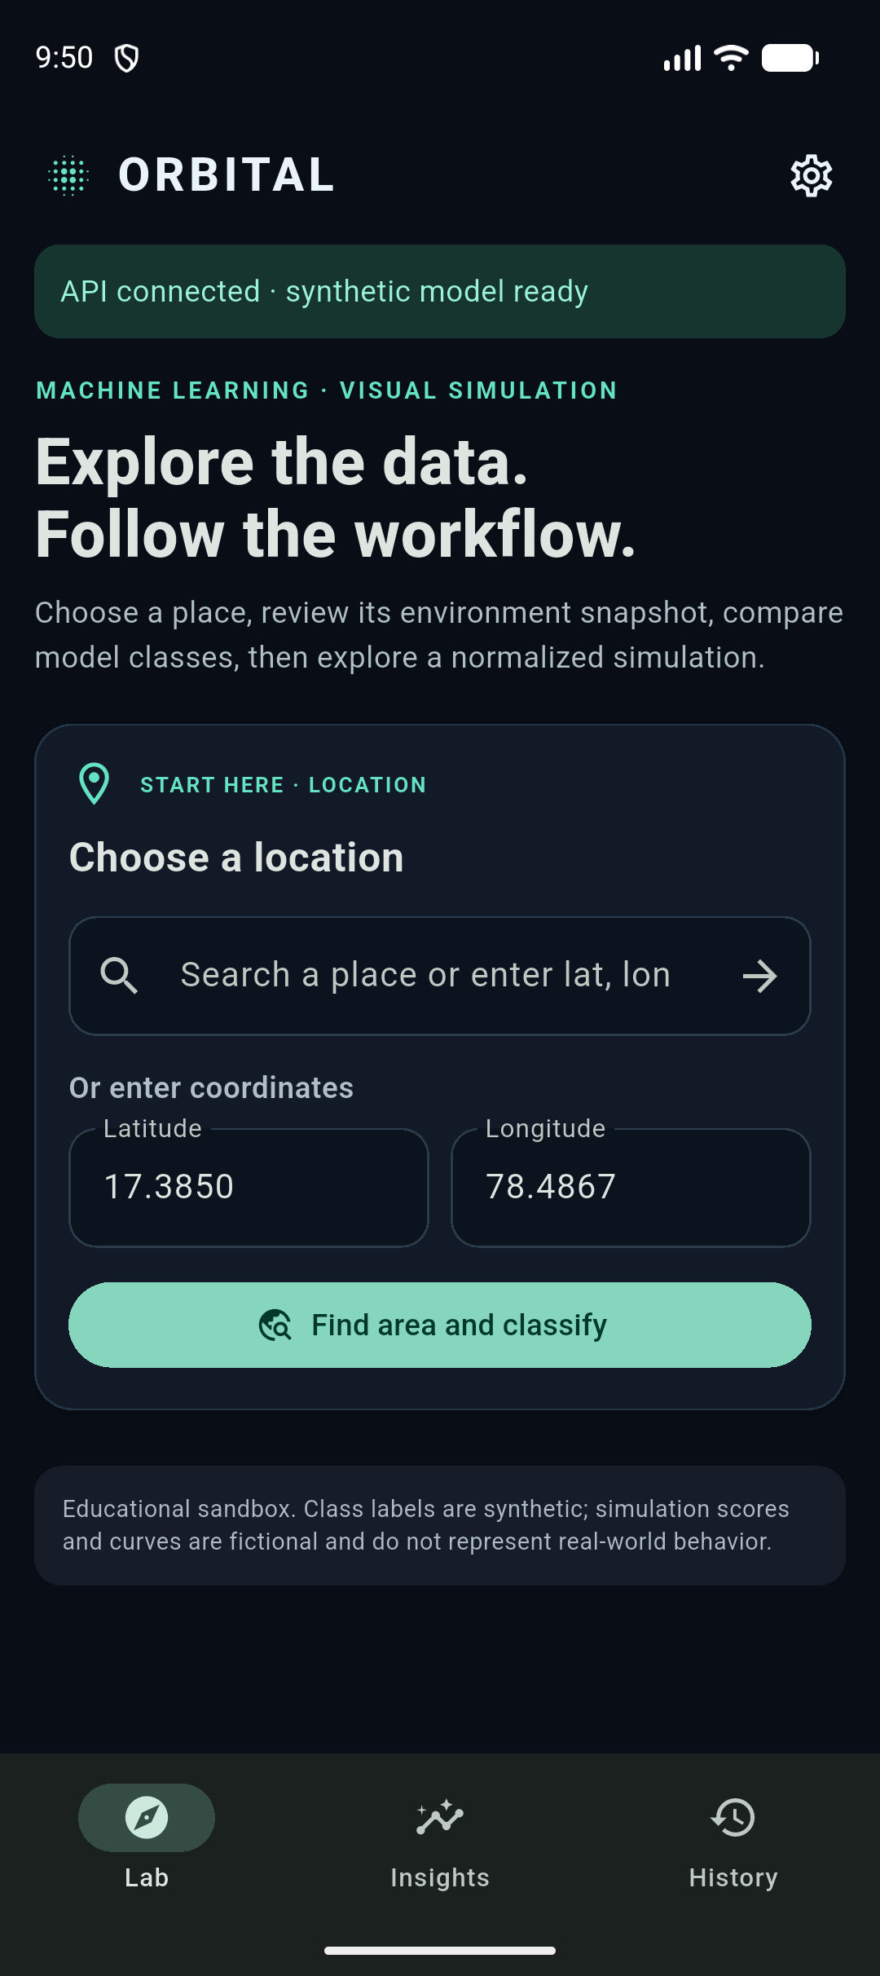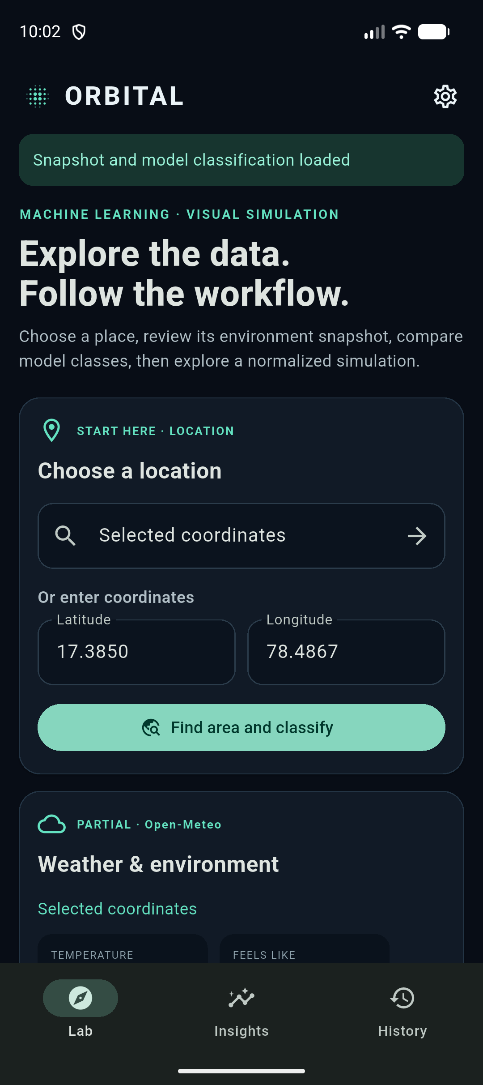

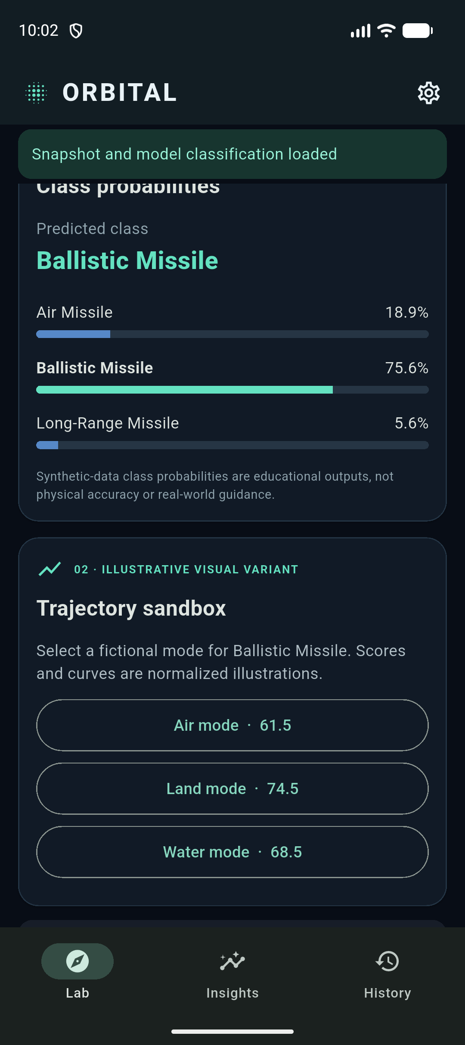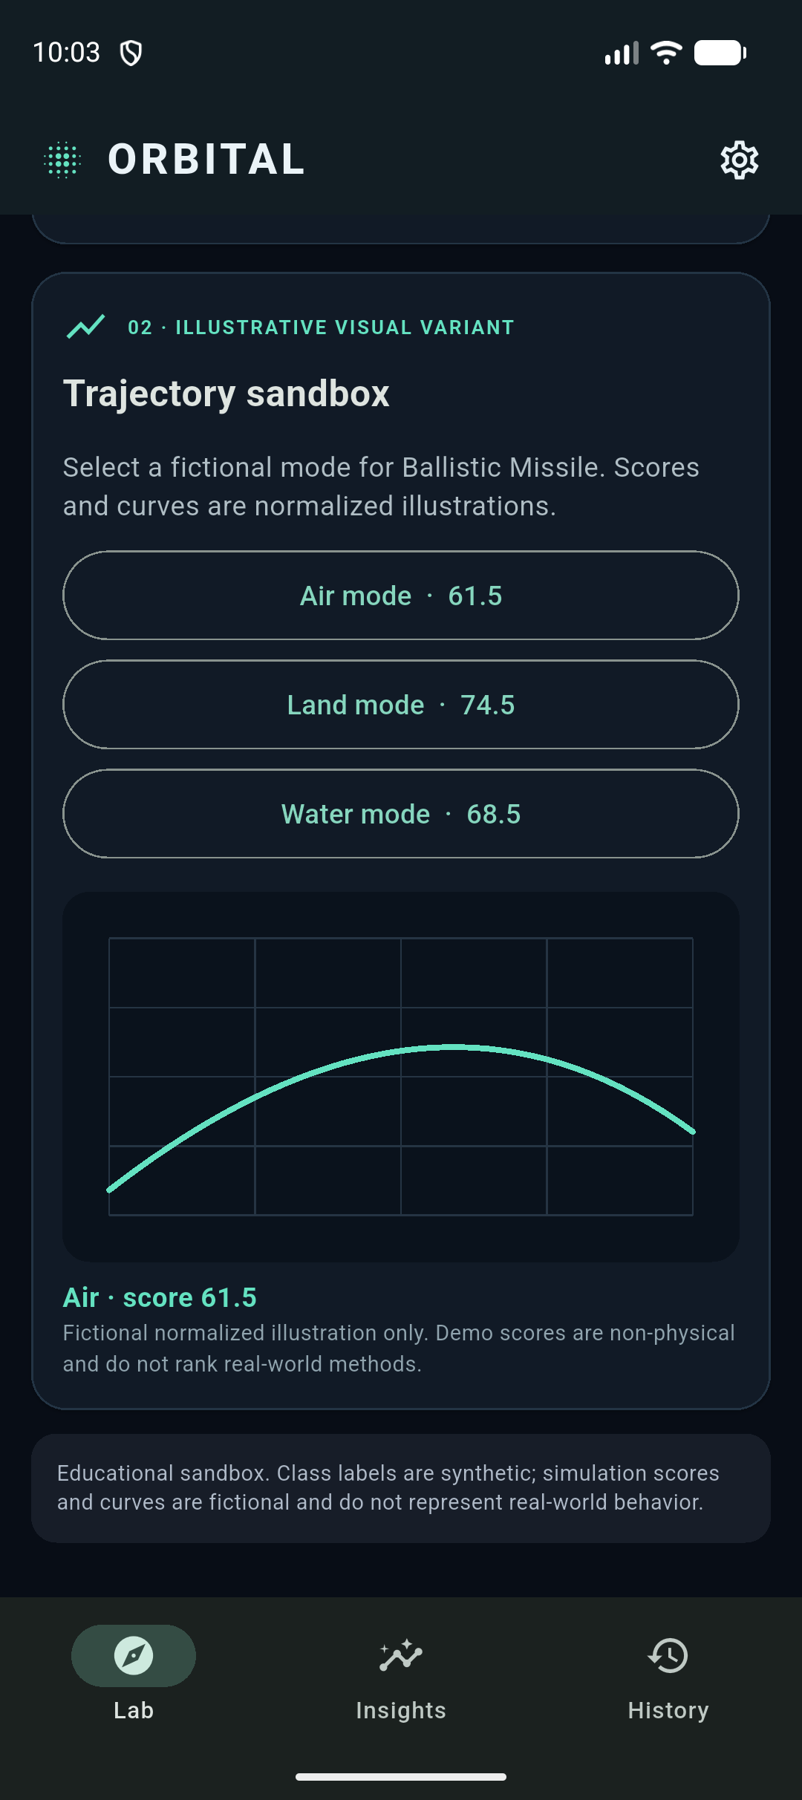

8. Future Enhancements

8.1 Environmental API Integration

- The application can be connected to environmental APIs to retrieve actual environmental information based on geographical coordinates.
- This will allow the application to process real temperature, humidity, wind speed, and other environmental parameters.

8.2 Database Integration

- A database can be introduced to store environmental records, classification results, and session history permanently.
- This will ensure that information remains available even after closing or restarting the application.

8.3 Dynamic Dashboard
- The dashboard can be enhanced to display updated environmental information and classification statistics.
- Environmental values, data source status, and classification results can be refreshed automatically whenever new information becomes available.

8.4 Advanced Classification Integration

- The current local classification mechanism can be replaced with a trained model or a validated backend classification service.
- This will allow the application to process real environmental datasets and provide more advanced classification capabilities.

8.5 Environmental Visualization

- Geographical maps and graphical environmental representations can be introduced to improve the visualization of environmental information.
- This will help users understand the relationship between geographical locations and environmental parameters.

8.6 Authentication and Authorization

- Authentication can be introduced if user accounts and saved environmental records are added.
- Role-based access control can also be implemented to provide appropriate permissions for different users.
9. Conclusion

The Environmental Classification Application Using Flutter demonstrates the implementation of a mobile application for managing environmental parameters and performing basic environmental classification. The application provides a simple interface for entering coordinates, modifying environmental values, selecting environmental categories, and viewing classification results.

The project successfully demonstrates the integration of Flutter UI components, local data processing, input validation, and result visualization within a single application. Its modular structure provides a foundation for further development and integration of real environmental data sources.

Although the current application operates using simulated data and a local classification mechanism, it establishes a useful starting point for developing a more advanced environmental information system. Future enhancements such as API integration, database connectivity, improved visualization, and advanced classification methods can increase its functionality and practical applicability.

References

- Flutter Documentation – https://docs.flutter.dev/
- Dart Programming Language Documentation – https://dart.dev/
- Flutter Material Design Documentation – https://docs.flutter.dev/ui/design/material
- Material Design Guidelines – https://m3.material.io/
- Flutter API Reference – https://api.flutter.dev/
- Dart API Reference – https://api.dart.dev/

